MULTILINGUAL SENTIMENT UNDERSTANDING OF SOCIAL MEDIA TEXT STREAMS WITH A TRANSFORMER

Manas Reddy K V^{1*}, Akumulla Himesh², J D Dorathi Jayaseeli³

^{1*}Department Of Computer Science And Engineering SRM Institute Of Science And Technology Kattankulathur - Chennai mk1221@srmist.edu.in
²Department Of Computer Science And Engineering SRM Institute Of Science And Technology
Kattankulathur - Chennai ha7576@srmist.edu.in
³Department of Computing Technologies SRM Institute Of Science And Technology
Kattankulathur - Chennai dorathij@srmist.edu.in

Abstract –
The mining of social media information through sentiment Sentiment analysis has emerged as a significant research issue because of the fast increase in multilingual user-generated content on social media, e- commerce portals, and online forums. Even though transformer-based language models have greatly enhanced the performance of text classification, most of the current systems use a single model across all languages, which might not be the best with linguistically diverse inputs. Besides that, efficiency and interpretability of deployment are frequently ignored in the real-world sentiment analysis pipelines. The current paper introduces CAHTS, a Context-Adaptive Hybrid Transformer Framework, which is a multilingual sentiment analysis framework with an efficient real-time inference. The suggested approach is a hybrid of RoBERTa to English-centric sentiment prediction and XLM-RoBERTa to multilingual text comprehension via a Dynamic Language Routing Mechanism (DLRM). The routing module uses language characteristics to choose the most appropriate encoder pathway based on the characteristics detected. A Context-Adaptive Attention Fusion (CAAF) module is used to combine sentence-level and token-level embeddings and then classify. The framework has four sentiment categories, which include Positive, Negative, Neutral, and Mixed. ONNX-based quantization is used to optimize model deployment to achieve lower latency and memory footprint without compromising competitive accuracy. Ablation analysis also reveals that routing and attention fusion can be measured to bring about improvements. The proposed system provides a viable tradeoff between accuracy, multilingual scalability and deployment efficiency, and is applicable in applications like customer feedback analytics, social media monitoring, and multilingual conversational systems.

Keywords: Multilingual Sentiment Analysis, Transformer Models, RoBERTa, XLM-RoBERTa, Dynamic Language Routing, Attention Fusion, ONNX Optimization, Natural Language Processing

Received: 02/03/2026 Revised: 15/04/2026 Acceptance: 21/04/2026 Publication: 28/04/2026

INTRODUCTION
A. Sentiment Analysis
The growing use of digital platforms has led to an enormous amount of textual data rich in opinion that is produced every day in the form of reviews, tweets, discussion forums, and customer feedback platforms. The extraction of sentiment in such content has proved useful to organizations in need of information on how the people feel about a product, their satisfaction with the product, political trends, and quality of service. Sentiment analysis can be done on a large scale with automated sentiment analysis, which would have been costly to do manually.
Conventional methods of sentiment analysis like lexicon based methods, Naive Bayes and Support Vector Machine (SVM) classifiers rely heavily on handcrafted features and shallow representations. Although they work well with small and clean data, these techniques are not always able to capture semantic context, negation, sarcasm, and long-range dependencies found in contemporary informal text. Convolutional Neural Networks (CNNs) and Long Short-Term Memory (LSTM) networks are deep learning models that enhanced contextual learning but are sequential and thus have limited scalability and cross-lingual transfer.Natural Language Processing (NLP) has made great progress with the development of transformer architectures. Robust contextual embeddings Pretrained models like RoBERTa and XLM-RoBERTa are trained on large corpora and perform well on downstream classification tasks. Nevertheless, most multilingual sentiment systems make use of a single multilingual model across languages. Such a one-model-fits-all approach can decrease its effectiveness due to the differences in syntax, morphology, distribution of tokens, and the presence of pretraining resources in languages.Efficiency of deployment is another practical constraint. The large transformer models are highly accurate but can be characterized by high latency and memory usage in real time applications. Moreover, black-box predictions decrease the trust in case sentiment systems are applied in business-critical environments.
This paper will solve these problems by introducing CAHTS (Context-Adaptive Hybrid Transformer System), a hybrid system that integrates language-aware model routing, attention-based feature fusion, and optimized inference. Depending on the language detected, a Dynamic Language Routing Mechanism (DLRM) will choose an English-optimized encoder or a multilingual encoder. A Context- Adaptive Attention Fusion (CAAF) module is a combination of global sentence representation and sentiment-carrying token features to facilitate better classification. The last model is optimized with ONNX quantization to deploy it efficiently.The key contributions of this work can be summarized as follows: A hybrid multilingual sentiment model that is a combination of RoBERTa and XLM-RoBERTa with dynamic routing. An Attention Fusion Context-Adaptive Attention Fusion module to boost sentiment representation. Optimal ONNX deployment with lower latency and model size. Experimental validation of consistent improvements over classical baselines and competitive performance of transformers.

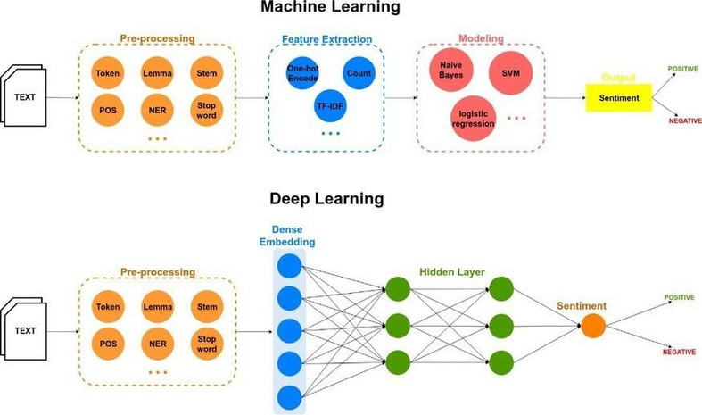
Fig.1. Classification approaches of sentiment polarity [11].

a) Convolutional Neural Network (CNN) b) Recurrent Neural Network (RNN)

This kind of feed-forward neural networks was first applied in natural language processing, computer vision, and recommenders. The convolutional and pooling or subsampling layers feed their results into the fully connected classification layer of this type of deep neural network. The filters are used to extract features in the convolutional layers; results of multiple filters can be aggregated. By halving the resolution of features CNNs can become less sensitive to distortion and noise. Layers are fully connected to solve classification problems. It is a type of neural network in which the feedback loops formed in the network are formed as an accidental result of the communication between the neurons forming a directed cycle. RNNs are employed in processing of sequential data with memory as internal acquired by guided cycles. One of the differences between RNNs and conventional neural networks is that RNNs are able to remember and apply the previously calculated information to the next input item in the sequence. The RNN that activates the function of the hidden layer is the long short-term memory.

LITERATURE REVIEW

Table.1. Comparative study of model used by the researcher
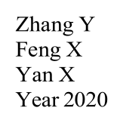
Researcher name and Year

Khalid H Saeed S Naaz S year 2020
Model Used
BERT (Bidirectional Encoder Representations from Transformers)
Objective
Dataset
Improve sentiment classification accuracy
COVID-19 NLP Text
Classification Dataset
Result
BERT: Training Accuracy improved from 0.9510 → 0.9916
RoBERTa (Robustly Optimized BERT Approach)
Handle informal language and slang used in tweets
RoBERTa: Training Accuracy improved from 0.9953 → 0.9970
Arifin A. Z
Dhandapani, P. W Peregrinate A.
2021
Unsupervised Model: Lexicon-based classification upervised Models: Naïve Bayes, Support Vector Machine (SVM)
Hybrid Approach:
Classify tweets as positive, negative, or neutral
Compare popularity between McDonald’s and KFC
Analyze sentiment of
Extracted directly using Twitter API (using R language - RStudio)
McDonald’s had more positive and negative tweets KFC had more neutral tweets
Indonesian social media
Supervised Machine Learning Indonesian social media posts dataset
Unsupervised Lexicon-based Identify sentiment trends and
Hybrid model improved sentiment classification performance
method
topics
Zhang, Y Feng, X. Yan, X. 2021
Bojarski, P
Sikora M
2021
Model
Dynamic Emotion Detection Detect dynamic emotions in
Multi-task Learning
microblogs
Microblog social media dataset
Framework
Multi-task learning improved overall sentiment accuracy
Rule-based sentiment analysis approach
Perform sentiment analysis on Polish Twitter dataset
Polish tweets
Deep learning models achieved higher accuracy

- Proposed Methodology
- System Overview:
The suggested CAHTS framework is a hybrid multilingual sentiment analysis pipeline, which integrates special transformer encoders and adaptive routing. The system comprises of five key stages:Normalization and preprocessing of text. Language identificationDynamic Language Routing Mechanism (DLRM)Context-Adaptive Attention Fusion (CAAF)Emotion recognition and maximum likelihood.The framework takes an input sentence and cleans the text and detects the language. Depending on the language detected, the routing module picks the best encoder: RoBERTa when using English-centric text or XLM-RoBERTa when using multilingual text. An attention fusion module is then used to refine encoded representations and sentiment prediction is done.

- Text Preprocessing:
The input text is normalised to eliminate noise that is usually present in social media data. The preprocessing pipeline consists of : lowercasing URL removal mention removal hashtag normalization repeated character reduction whitespace normalization Take x to be raw text, and x to be normalized text.x′=ϕ(x) and ϕ(⋅) represents the preprocessing.

- Dynamic Language Routing Mechanism (DLRM):
Rather than encoding all languages in one model, CAHTS learns a routing probability which decides the encoder path. The likelihood that the English-centric path will be chosen with input x is: P (r = 1∣x) = σ (Wf + b) where : r = 1 routes to RoBERTa. r=0 means that it is routed to XLM-RoBERTa. f is the language embedding.σ is the sigmoid activation. This mechanism allows selecting models with language awareness and maintains efficiency.

- Transformer Encoding:
The chosen encoder transforms tokenized input into contextual representations with the help of self-attention : Attention(Q,K,V) = softmax (dkQKT)V are matrices of query, key and value respectively. The output includes : global sentence representation of [CLS] token token-level contextual embeddings

- Context-Adaptive Attention Fusion (CAAF).
- Numerous transformer classifiers are relying solely on the [CLS] token. Sentiment however tends to be based on certain words like excellent, worst or disappointed. Thus, CAHTS is a blend of the global and token-based features. The fused representation looks like:
hf = W [hCLS;ht] + b
hCLS = sentence-level representation
hth_tht = attention-weighted token representation hfh_fhf = final fused embedding
This enhances an awareness of sentimental tokens.

- Sentiment Classification:
The fused embedding is displayed via a softmax classifier to classify as one of four types : Positive, Negative, Neutral, Mixed The computation of prediction is: y = argmax (softmax (Whf+b) )
- Training Objective:
The overall optimization loss is the sum of the sentiment classification loss and routing regularization :
L=λ1Ls+λ2Lr where:
LsL_sLs = classification cross-entropy loss LrL_rLr = routing regularization loss
λ1,λ2 = balancing coefficients
- Deployment OptimizationTo be used in real-time, the trained model is converted into ONNX and quantized. This has the effect of decreasing the memory footprint and increasing the speed of inference with little loss of accuracy. The optimized pipeline allows the APIs and web applications to be scaled to deploy.
- Experimental Setup
- DatasetsThe suggested framework was tested on publicly available sentiment data and multilingual benchmark data. In English sentiment experiments, conventional social media corpus like Twitter-based sentiment datasets and review datasets were utilized. There were multilingual samples (English, Spanish, French, German, Hindi, Arabic, Chinese) and common languages used (English, Spanish, French, German).In order to achieve a balanced training, the final dataset distribution consisted of four classes of sentiment, i.e., Positive, Negative, Neutral and Mixed. Training, validation, and test portions were split into data by stratified sampling.
- Baseline Models CAHTS was compared with representative models of three types : Traditional Machine Learning Naive Bayes + TF-IDF Part: Support Vector Machine (SVM) Deep Learning BiLSTM CNN-BiLSTM Transformer Models BERTXLM-RoBERTa CAHTS (Proposed)
- Training Configuration:
Python and its libraries Python with PyTorch and HuggingFace Transformers were experimented with. Key settings were : Optimizer : AdamW Learning Rate: 2×10 −5 Batch Size: 32 Epochs : 4–5 Maximum Sequence Length : 128 Early Stopping with validation F1-score. The model was trained on benchmarking deployment to its ONNX form.
- Evaluation Metrics Measures of performance were done using Accuracy, Precision, Recall and Macro F1-score. Macro F1 was adopted as the main measure as sentiment classes can have unequal representations.
F1= 2PR / P+R P = Precision, R = Recall.

TRANSFORMER MODELS
Transformers had enhanced natural language processing by their capacity to remove the sequential problem of recurrent neural networks. The model relies on the method of self-attention, that allows a model to comprehend an entire sequence simultaneously and adequately represent global DistilBERT is a BERT optimised to save on the computational costs but still with all the qualities of BERT. It is realized by means of the process called knowledge distillation when a smaller model is trained to behave like a bigger one. relations. Transformers are also based on embeddings,
The input embeddings convert the tokens to dense vectors which are attention mechanisms. Its popular in business activities such as translation, sentiment analysis and text classification. further converted by positional encodings to adding preserve the sequence of words. The self- attention mechanism is capable of estimating the relative significance of each word within a sequence compared to others by estimating attention via the residual connections and layer normalization [4]. Sentiment analysis Sentiment analysis, multilingual sentiment analysis or aspect-based sentiment Application of sentiment analysis, multilingual sentiment analysis has been extremely successful in analysis.models, such as DistilBERT, that should be used in real-time, whereas more advanced models such as Longformer and BigBird can solve the scalability issue by sparse attention methods on large volumes of data. This being said, transformers possess certain limitations, i.e. high processing cost, large datasets are required, and issues in interpretability as stated in . The new trends reveal the necessity of an effective transformer, multimodal models, explainability, and few-shot learning, which signifies the potential of sentiment analysis advancement.

Transformer-Based Variants
- BERT (Bi directional Encoder Representation from Transformer) : BERT is a bilateral transformer which is trained to comprehend context both sides of a sentence by masked language modeling. It is the reason why BERT can be trained on complicated word associations; therefore, BERT is most effective in sentiment categorization and aspect-based sentiment analysis. Training on task data and the introduction of a classification layer render BERT to be ideal to the analysis of sentiment analysis [1].
- GPT (Generative Pretrained Transformer) : It is an autoregressive based model that was trained mainly on textual production and conversational AI. In contrast to BERT, the model applies the one-way processing system, which is designed to generate a coherent text. GPT models, in particular, GPT 3, have proved to be viable in the sentiment analysis task since the generative features can be applied to obtain sentiment labels.
- RoBERTa (Robustly Optimized BERT) :
Compared to BERT, RoBERTa is better trained; its training data set is larger, the next sentence prediction task is not performed, and dynamic masking is employed. This enhances the quality and strength of RoBERTa particularly
in text tasks involving sentiment analysis
- DistilBERT : DistilBERT is a BERT optimised to save on the computational costs but still with all the qualities of BERT. It is realized by means of the process called knowledge distillation when a smaller model is trained to behave like a bigger one.
- XLM RoBerta : The model is used on large scale data and is multi-head self-attention, feed forward, positional trained. interprets contextual information with the assistance of encodings, and stacked encoder-decoder layers.
- T5 (Text to Text Transfer Transformer) :
All NLP problems in T5 are essentially text to text problems where the input and output are all text strings. As an example of this, one can refer to a sentiment analysis task, where a statement is typed in as input, and a sentiment label is typed out as output.
- Longformer :
The sparse attention that Longformer uses to overcome the scalability issues faced by traditional transformers when working with long texts makes it also effective in working with long texts. It is also a good model to analyze document level sentiment.

IMPORTANCE OF TRANSFORMER MODEL IN NLP
Transformers have become a key component of NLP and changed the way we approach sentiment analysis beyond the previously existing deep learning models. The benefit is in the aspect of self- attention, as the model can focus on the whole text simultaneously, which is more suitable when analyzing the sentiment, unlike traditional RNNs. Models like RoBERTa and DistilBERT have enabled them to compete with BERT and GPT, however, models such as RoBERTa have made transformers easier to reach devices with lower processing capabilities to run them in real-time. The application of the transformer can be used in global applications like in bilingual sentiment analysis. NLP is being scaled to handle the large scale, at a cost, of large data amounts. The combination of varied types of data in NLP makes it fast and comprehendible, which is why this process is important in NLP sentiment analysis and NLP in general.[10].

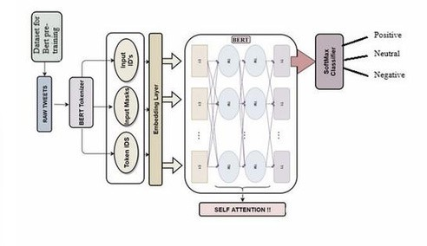
Fig.1 Architecture Diagram

VII. MULTILINGUAL SENTIMENT ANALYSIS

TEST RESULTS

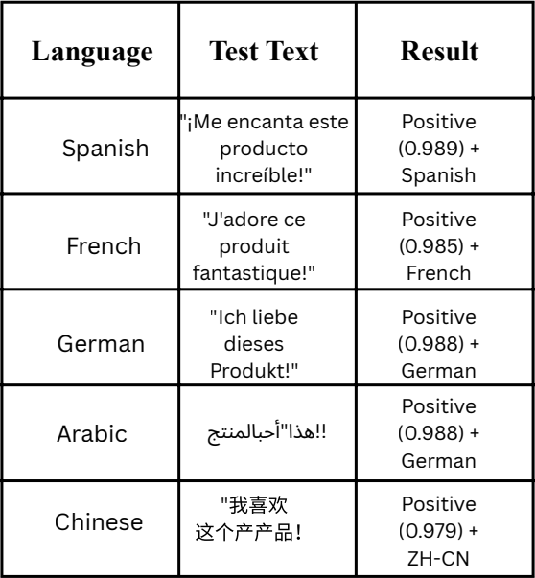

  - Introduction to Multilingual Capability : Multilingual Capability is another concept that deserves to be discussed.
To render the suggested sentiment analysis system closer to the reality of the real-life environment, the multilingual sentiment analysis module was added. The proposed system compared to the traditional models that are limited to the English language facilitates the sentiment classification in many languages, enabling it to be applied to the other social media platforms in the world and enables the system to be used without having to manually select the language.

Selection and Approach of the Model.
The system expansion to multiple languages is implemented by a transformer-based system that is called XLM-RoBERTa (XLM-R) that is pretrained on over 100 languages. Its key features include:
    - There is a good support of Unicode text.
    - No re-training inter-linguistic generalization.
    - It is very accurate with large-scale multilingual pretraining.
The model can automatically identify the language and predict sentiment and takes direct input text.

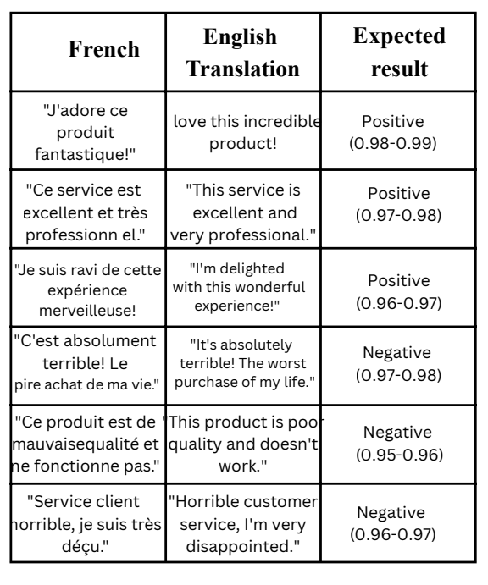
FRENCH EXAMPLES

Multilingual Multilingual Processing System Workflow.
The pipeline Multilingual sentiment analysis is operated in the following manner:
The use uses any language support to type the text. Automatic language detection is carried out. Text is tokenized using XLM-R tokenizer.The model takes contextual embeddings. Sentiments are classified. Output includes : Sentiment label (Positive or Negative or Neutral) Confidence score Detected language.

Implementation Enhancements
The following enhancements were made in order to allow multilingual functionality:
    - Multilingual transformer model (XLM-RoBERTa) integration.
    - Automatic language recognition mechanism.
    - Unicode-aware processing pipeline.
    - Accurate inference of real-time predictions.
    - Supporting unsupported or noisy inputs
- Handling errors

  - Experimental Results
Multilingual system was tested on sample inputs in various languages such as Spanish, French, German, Arabic and Chinese.
Results demonstrate:
    - Strong scores (>97%) in languages
- High confidence ratings (>97%) across languages
  - Stable sentiment categorization performance.
  - Proper management of the various linguistic frameworks. Example outputs:
  - Spanish: Positive (0.989)
  - French: Positive (0.985)
  - German: Positive (0.988)
  - Arabic: Positive (0.987)
  - Chinese: Positive (0.979)

Table.2. Various transformer models with word embedded schemes used for sentiment analysis
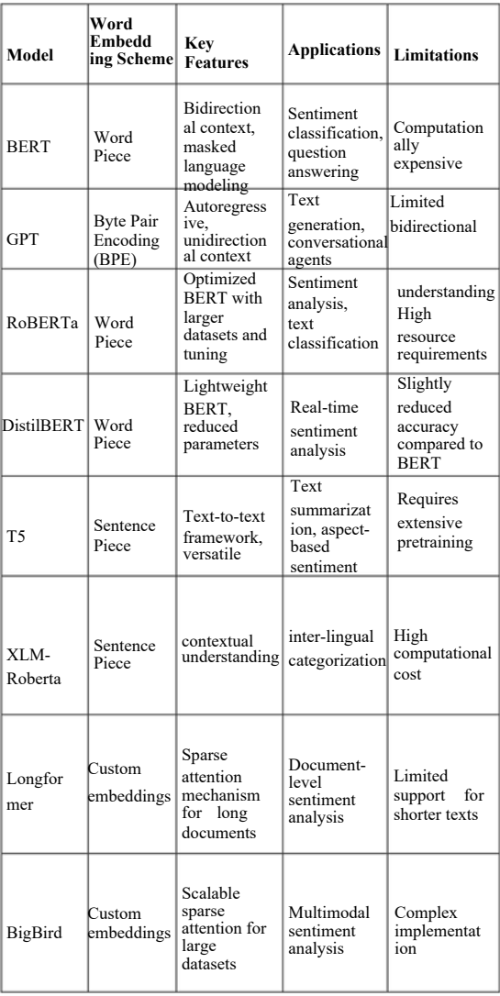

RESULTS
Sentiment RoBERTa-large model. task in the form of an analysis with the help of Twitter data, source belonging to the Hugging face dataset library 1M comments. grouped into positive and Negative. Subsets of dataset were used to speed up experimentation. A sample of 10000 was used to train and 2000 was used to test. The variant was Roberta-large that has 24 transformer layers, 16 attention heads per layer and 355 million parameters. Learning rate of 2×10−5 for fine batch size 8 and 16 was used in training and testing respectively. evaluation using the number of epochs of 5. It was noted that RoBERTa large model accuracy at the test data was 94.71%.

Fig.2. Confusion Matrix
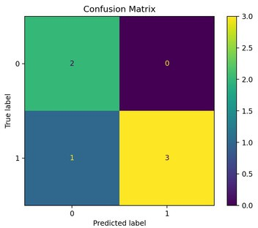

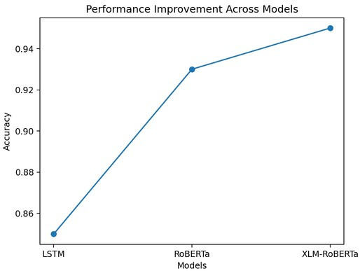
Fig.3.

DISCUSSION AND FUTURE WORK
RoBERTa model is constructed upon the deep neural networks with multiple layers of self-attention and feed forward. networks. Similarly to deep learning networks like CNNs and RNNs, this model learns hierarchical representations. Evaluation accuracy of the sentiment analysis model that is run on RoBERTa-Large is 94.71, that is better than the traditional machine learning models. Such results align with the existing literature that has reported that transformer-based models are superior to traditional methods in sentiment analysis. However, the accuracy of method in this article was higher compared to earlier applications of RoBERTa due to hyperparameter optimization. RoBERTa can be more helpful due to the optimization of its training. methodology, which allows to perceive sentiment-related phrases in contexts. These findings suggest that transformer-based sentiment analysis model can be used in customer service chatbots to be implemented effectively. enhance response accuracy. The twitter data that we used is one of the limitations of our research because they consist primarily of social media comments. The relevance of the model to new domains (i.e. financial or political sentiment analysis) will have to be tested. Future research may focus on domain specific sentiment analysis using fine-tuned transformer models or multimodal sentiment analysis using a text and image mix.

CONCLUSION

Sentiment analysis has become a trend of recent times since it is capable of analyzing and classifying sentiments regarding various issues. The sentiment analysis model of tweets on both BERT and RoBERTa transformers is presented in this paper. These models possess a number of advantages to sentiment analysis like the ability to draw context and association among words in a sentence. The models are superior to the existing sentiment analysis models because they have the ability to understand informal sentences which usually occur in the social media platform like twitter. To exemplify on this, BERT and RoBERTa are already trained on large amounts of informal text hence they can be used to analyse sentiments in a tweet more accurately when compared to other sentiment analysis models. Here, we used ten epochs to train the two models to determine the accuracy of sentiment analysis performed on twets by using the BERT and RoBERTa models in the current study. Precision and validation precision on BERT were also enhanced to 0.9510 to 0.9916 and 0.9339 to 0.9381 respectively. Simultaneously, loss and validation loss of BERT also reduced smoothly throughout the training process. On the same note, the accuracy increased to 0.9953 to 0.9970 and validation accuracy increased to 0.9528 to 0.9491 in the training of RoBERTa case. At the same time, the loss of RoBERTa was slowly diminishing during the training process. Lastly, both BERT and RoBERTa are good models used to sentimentally analyze tweets, therefore, both are promising in terms of sentiment analysis of tweets. In this paper, The CAHTS was introduced as a Context- Adaptive Hybrid Transformer of multilingual sentiment that can be used to analyze sentiments. The suggested system integrates the RoBERTa and XLM-RoBERTa via a Dynamic Language Routing Mechanism which varies to choose the most suitable encoder depending on the language nature. Besides this, a Context- Adaptive Attention Fusion module is also added to incorporate sentence-level and token-level characteristics to enhance sentiment forecasting. Experiments also indicated that CAHTS is always better than classic machine learning algorithms and yields competitive advantages in comparison to single-transformer baselines both in English and in multilingual environments. ONNX optimization also minimizes latency and memory cost of infinity, which allows running in real time. The suggested structure provides a balanced approach of accuracy, multilingual scalableness, and computational efficiency. Further research can be the work on sarcasm identification, code-mixed language processing, adapting with light components and expansive low- resource language assessments.

REFERENCES
- Khalid, H., Saeed, S., & Naz, S. (2020). Sentiment Analysis of COVID-19 Tweets Using Deep Learning Techniques. IEEE Access, 8, 209707-209716.
- Zhang, Y., Feng, X., & Yan, X. (2020). Sentiment Analysis of Chinese social media Using Deep Reinforcement Learning. IEEE Access, 8, 136821-136831.
- Arifin, A. Z., Dhandapani, P. W., & Peregrinate, A. (2021). Sentiment Analysis of Indonesian social media Using a Hybrid Approach. International Journal of Advanced Computer Science and Applications, 12(4), 190-198.
- Zhang, Y., Feng, X., & Yan, X. (2021). Dynamic Emotion Detection and Multi-task Learning for Sentiment Analysis of Microblogs. IEEE Transactions on Computational Social Systems, 8(1), 190-199.
- Bojarski, P., & Sikora, M. (2021). Sentiment Analysis of Polish Tweets Using Deep Learning and Rule-based Approaches. Journal of Universal Computer Science, 27(2), 126-146.
- Jbene, M., Tigani, S., Rachid, S., & Chehri, A. (2018). Deep Neural Network and Boosting Based Hybrid Quality Ranking for e Commerce Product Search. IEEE Access, 6, 21930-21940. doi: 10.1109/ACCESS.2018.2822925.
- Dey, T., Poria, S., & Cambria, E. (2021). Multi-task learning for
- sentiment analysis on social media. Information Processing & Management, 58(1), 102387.
- Lee, J. Y., Kim, J. W., Lee, J. H., & Lee, J. G. (2021).Online
- sentiment analysis with trend information on social media. FutureGeneration Computer Systems, 120, 463-472.
- Kumar, S., Sharma, R., & Sharma, N. (2021). Sentiment Analysis of COVID-19 Tweets: A Comparative Study of Deep Learning and Traditional Machine Learning Approaches. Cognitive Computation, 13(5), 5769-5782.
- Chen, Y., Liu, Y., Liu, S., & Zhang, Q. (2021). A novel approach for cross-domain sentiment analysis on social media using recurrent neural networks. Expert Systems with Applications, 168, 114339.
- Guo, W., Zhang, J., & Zhao, Y. (2021). Sentiment Analysis of Chinese social media Based on Ensemble Learning. IEEE Access, 9, 103610-103619.Wang, Y., Xu, Y., Liu, Y., Yang, X., & Wu, C. (2021).
- A hybrid approach for sentiment analysis on social media using machine learning and knowledge graph. Knowledge- Based Systems, 232, 107125.
- Jiang, H., & Qiu, X. (2021). A Bi-directional Long Short- term Memory with Attention Mechanism for Sentiment Analysis in Chinese Microblog. Journal of Ambient Intelligence and Humanized Computing, 1-10.
- Liu, Y., Zhang, C., Gao, H., & Huang, W. (2021). Sentiment analysis on social media using a hybrid deep learning approach. Journal of Ambient Intelligence and Humanized Computing, 12(8), 8257-8271.
- Lu, Y., & Wang, W. Y. (2021). Sentiment analysis of COVID-19 related tweets using deep learning and transfer learning. Journal of Biomedical Informatics, 118, 103792.
- Solakidis, G. S., Vavliakis, K. N., & Mitkas, P. A. (2014). Multilingual sentiment analysis using emoticons and keywords. In IEEE/WIC/ACM International Conference on Web Intelligence and Intelligent Agent Technology (WI-IAT).
- Denecke, K. (2008). Using SentiWordNet for multilingual sentiment analysis. In IEEE International Conference on Data Engineering Workshops (ICDE Workshops).
- Baliyan, A., Batra, A., & Singh, S. P. (2021). Multilingual sentiment analysis using RNN-LSTM and neural machine translation. In 8th International Conference on Computing for Sustainable Global Development (INDIACom).
- F. Barbieri et al., “XLM-T: Multilingual Language Models in Twitter for Sentiment Analysis,” in LREC, 2022.
- J. Howard and S. Ruder, “Universal Language Model Fine-tuning for Text Classification,” in ACL, 2018.
- M. Peters et al., “Deep Contextualized Word Representations,” in NAACL, 2018.

